Retail-Bank Customer Clustering with K-Means
Short name: KMBank. Codecademy k-means lab moved from 8×8 digits to a 2,000-row retail book (five planted personas).

Problem Statement
Retail, Collections, and CRM still talk past each other with one average customer. The book is unlabeled for this exercise. We need compact groups, a prototype row in dollars and percents, and a way to drop a new applicant on the nearest prototype — without pretending the cluster is a PD or an approve/decline.

Solution Strategy
- 2,000 customers × 10 mixed-unit columns. Hold segment out of .fit.
- Z-score first (score 477–834 vs util 0–1). From-scratch assign → update, then KMBank.KMeans.
- Domain k=5 (Prime, Saver, Revolver, Stressed, Affluent). Confirm with an elbow.
- Back-transform centroids. Majority-map cluster → persona. Purity + ARI.
- Infer four new applicants. Simulate k / n / noise / n_init. Unscaled ablation.

Solution
Card | k | Inertia | Purity | ARI
Scaled 10-feature book | 5 | 4,670 | 0.978 | 0.945
Unscaled (score owns distance) | 5 | — | 0.786 | —
Risk columns only | 5 | — | 0.702 | —
k=3 on full book | 3 | 7,246 | 0.600 | 0.607
Noise σ=0.8 on scaled X | 5 | 16,810 | 0.863 | 0.698
n_init=1 (one random start) | 5 | 5,305 | 0.790 | 0.695
Four walk-in rows mapped Prime / Stressed / Affluent / Revolver. Cluster ids are not those names until the majority vote (or a glossary) is applied.
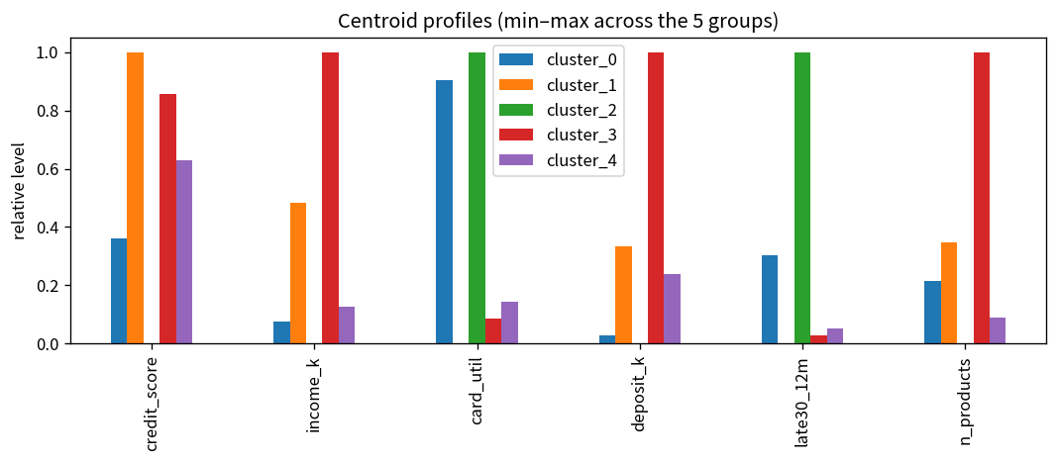
Figure. Five prototypes in original units — the slide a branch manager can read.

Key Takeaways
- Scale before you cluster. Skip it and credit score swallows DTI and utilization (purity 0.978 → 0.786).
- Inertia keeps falling after k=5; five is the retail glossary plus a compatible bend.
- A centroid is a customer. Show it in dollars, not in z-units.
- n_init=1 is a real risk (purity 0.79). Restart and keep the lowest J.
- Same pipeline for branch mix or card-util bins. Not a scorecard, not a SAR, not pricing.

